Are you interested in reducing children’s challenging behaviors?

Buffalo County was selected by the Nebraska Children and Families Foundation to work with local partners to develop and implement a long range plan to support the social emotional development of young children (birth-8 years). This initiative is called Rooted in Relationships and is coordinated locally by Buffalo County Community Partners.
One part of this initiative is to implement the Pyramid Model, an evidence based framework for improving children’s social emotional development and reducing challenging behavior. Childcare Providers in Buffalo County will have the opportunity and support needed to implement this model in their programs. Support includes professional development in the form of training and on-site coaching as well as financial support through training and coaching stipends and grants.
Please join us to learn more about this opportunity:
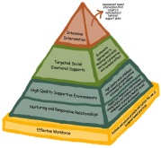
Informational Meeting
April 29, 2019—6:30 p.m.-7:30 p.m.
ESU 10—Room A
**Refreshments Provided**

Please RSVP to:

Tana Miller
Behavioral Health Coordinator
Buffalo County Community Partners
HealthyMINDS@bcchp.org | (308) 865-2278
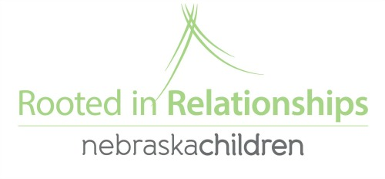
PO Box 1466, Kearney, NE 68848

