Buffalo County

Youth Advisory Board

HANDBOOK
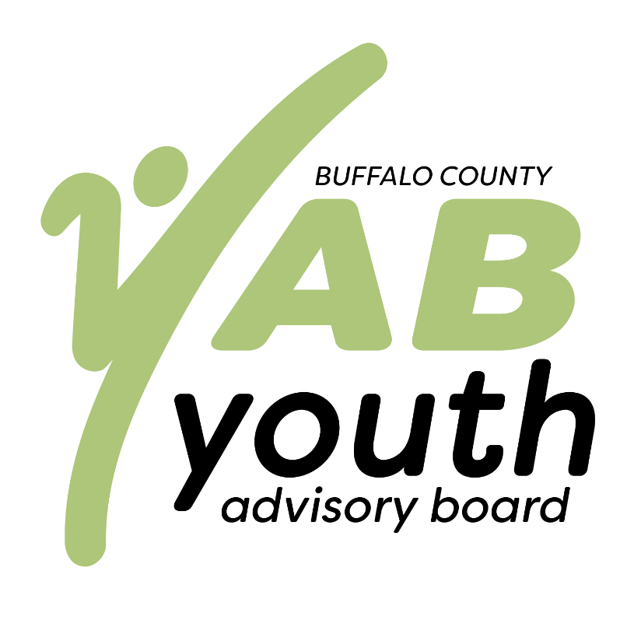

Welcome to Buffalo County Youth Advisory Board (YAB). We hope you have a positive and productive experience serving as a youth advisor. To help with this, we are providing you with a copy of our parent/student handbook. Please read this information carefully; it will acquaint you with updated YAB policies and procedures, as well as Buffalo County Community Partners’ youth policies.

What is YAB?
*youth-led, youth-based, youth-driven*
YAB is a program and philosophy that recognizes youth as valuable voices and empowers them as equal community leaders to bring about positive change. YAB is open to and comprised of youth from all high schools across Buffalo County and supported by local funders and adult facilitators, connected through Buffalo County Community Partners. Youth tackle a range of social problems that concern them, from safety, mental health, and substance abuse to the economy and environment.
The following policies are put into place to make sure our program runs in the best way possible and to ensure success from both the youth and the staff. These policies also allow youth to learn leadership skills and how a successful program is run. These policies have been reviewed and approved by the Community Partners Board of Directors. Any revisions will be proposed by the CEO to the Executive Committee for their consideration and recommendation to the Board of Directors for approval. The policies and benefits outlined in this document are subject to review and revision by the Board of Directors at any time, without notice. These policies and procedures are not all inclusive, nor can they anticipate every circumstance.

Non-Discrimination Statement
Buffalo County Community Partners is committed to the principle of equal opportunity in employment. No person will be subject to discrimination in any project, program, or activity because of race, color, religion, sex, national origin, age, medical condition, disability, veteran status, marital status, sexual orientation, gender expression, gender identity, or any other status protected by law.
YAB Code of Conduct
As a volunteer, contractor and/or employee, I realize that I am subject to a code of conduct to uphold the mission of Buffalo County Community Partners to assess, promote, and strengthen the health of Buffalo County residents. In so doing, I agree to abide by the following principles:
• adhere to this Policy in professional as well as personal conduct
• treat each other with respect, courtesy, compassion, honesty, and fairness
• respect different values, beliefs, cultures, and religions
• value the contribution of the people I work with and work co-operatively
• commitment to openly welcome, meaningfully engage, and fully incorporate both traditional and unique voices in our operational culture, values, norms, and behaviors, including external interactions
• acknowledge trauma present within affected populations and take action to ensure policies and practices employed promote healing and minimize any further trauma
• regularly check our own perceptions and attitudes and offer employees, contractors, and volunteers learning opportunities at least annually
• maintain our practices of data driven decision-making and facilitating best practice in each community
I promise to uphold these codes of conduct principles in my work as a volunteer, contractor and/or employee of Buffalo County Community Partners. I will make every effort to best serve the organization for which I volunteer, contract, or work.

Attendance Statement
Prioritize attendance at YAB meetings. Meetings will be regularly held on the third Sunday of each month. Notify the program manager and/or CEO prior to meeting time if unable to attend for an excused absence.
Youth Transportation
At times youth may require the assistance of employees to provide a ride from the program site to guardian/parent home. When transporting volunteers 18 years or younger, a guardian’s written consent will be secured prior to travel. In addition to ‘employee vehicle use’ policy, it is required of all employees to:
- Always provide two adult employees in the vehicle.
  - Communicate with the CEO when not applicable. A written plan will need to be in place.
- Use of electronic devices while driving is prohibited.
- All occupants must wear seat belts.
- Employees must ensure youth enter home before departing.
- Employees will ensure all youth are picked up from meetings or events before departing. Youth will not be left unaccompanied at close of event or meeting. Parents and guardians are asked to plan transportation to ensure youth have transportation options.
Parents/Guardians are responsible for finding adequate transportation for youth participants. Parents/Guardians are responsible for the cost of youth transportation.
Adult Volunteers
In order to ensure that YAB remains a youth-led, youth-based, and youth-driven organization, adults are expected to request permission from the program manager and/or CEO prior to attending private YAB meetings.

Youth Safe Environment
To ensure the safety of youth participating in activities of Buffalo County Community Partners, it is required of all employees to ensure these practices are in place for all youth programs:
1. Youth should not be in situations where they are alone with another youth for more than a few minutes.
2. Employees will refrain from touching youth at any time or occasion. It is a child’s right not to be touched.
3. Model positive self-expression to express views. Model motivational interviewing techniques, facilitation techniques, trauma informed strategies and promote self-care to support youth development.
4. All youth programs should have an adult mentor for every ten youth.
5. Faculty, employees, and volunteers should avoid situations where they are alone with one youth. Plan ahead to ensure adequate number adult mentors are available to support youth programs.
6. Personal space will be respected by all participants. Appropriate interactions with youth are always visible, open, not secretive, and avoids contact with body. Interactions should be in response to the request of the youth and not imposed by the adult.
7. Youth are encouraged to refrain from harmful acts that affect the social-emotional wellbeing of others. This includes hazing, blaming, or secret initiations.
8. Youth will remain in sight of employees at all times.
9. Avoid placing youth of widely differing ages in the same group. If this is not possible, closely supervise the group for appropriate youth to youth interactions.
10. Guardians are welcome to visit the program after they have called ahead for permission to attend. Guardians or other adults can be asked at any time to leave the program area.
11. Employees will ensure that all youth have a ride home from the program meeting before departing the program area.
12. All employees leading youth programs are expected to be trained in Youth Mental Health First Aid to ensure best practices if a youth experiences a mental health crisis (anxiety attack, panic attack, etc.). Steps to follow include:
a. If youth safety or health is in immediate danger call 911, ensure the safety of others, and contact the CEO right away.
b. Assess the situation to determine the first call, either an emergency 911 call or guardian.
c. Ensure the safety of the youth and other youth.
d. Ensure guardians are contacted.
e. Follow Youth Mental Health First Aid practices by ensuring guardians and youth have resources: for example, Buffalo County Crisis Mobilization hotline or Suicide Hotline.
f. Notify the CEO after youth is safely with guardian or sooner if assistance is needed.
13. The physical and emotional state of all youth is observed each time they participate. Signs of suspected child abuse must be reported.
14. Disciplinary measures never include use of physical punishment or failure to provide necessities of care. Nor should punishments single out an individual for group ridicule.
Safe Communications
Communication is vital to the success of youth and adult partnerships. Employees will model effective communication to develop youth leadership and youth forms of self-expression. Adults, volunteers, and youth may take on the role of advocate to engage more youth to join in a collaborative effort or shared agenda. The following areas are important to the success of youth and adult partnerships:

a. Youth and employees will refrain from use of profane language, written or oral, or acts, including gestures.
b. Employees will ensure youth and adults refrain from entering into inappropriate conversations and topics. Appropriate conversations are inclusive, non-judging, and age appropriate.
c. Employees will facilitate youth controversial topics in a neutral stance to show the organization’s view as impartial. Employees will not share their own individual biases in youth communication.
d. When encountering topics with opposing views, employees will present to youth options for speakers, teaching materials, and resources to assist youth in learning more about opposing views in order to find common interests.
e. Employees will work with youth to reach consensus decision making.
f. Employees will work with youth to explore individual youth views by asking questions to lead the youth group in better understanding each other. When consensus is not agreed upon, employees will not require the class to reach an agreement.
g. When consensus is not reached or clarity on inappropriate or controversial matters, bring conversation to the CEO’s attention
Incident Protocols
Employees are required to report to the CEO if any of the above items 1-14 are not followed. If an injury, damage to property, or other person occurs employees are required to immediately notify the CEO and complete an incident report within 12 hours of the incident and submit it to the CEO. Youth referred to a program by probation, diversion, counselor, or other provider, they should be notified in writing within 12 hours of the incident. It is a safe protocol to ensure the safety of youth, employees, and the organization to call the CEO, even when in question.

Youth Discipline
For the safety of employees and youth served by this organization, youth are encouraged not to engage in activity that causes or creates a reasonable likelihood that it will cause a substantial disruption or interference with any class activity, health, safety, well-being, or the rights of other youth, employee, visitors, or property.
Disciplinary Actions
Any youth conduct that, in the opinion of Community Partners, interferes with or adversely affects the agency and/or mission is sufficient grounds for disciplinary action. This action can range from verbal counseling to immediate discharge. It is our general policy to follow progressive disciplinary procedures. Community Partners reserves the right to determine the appropriate level of discipline for any inappropriate conduct and reserves the right to dispense with counseling at the discretion of the CEO and employee. It is our general policy to take disciplinary steps in the following order:
• Verbal counseling - A documented meeting between the employee and youth during which the employee should explain in detail the reasons for the verbal counseling.
• Written counseling - Should verbal counseling not correct the behavior within the reasonable allotted time, written counseling may be given to the youth. This counseling should describe the problem and the action required to correct it.
• Dismissal from youth program – Youth will be dismissed from program.
Parent/Student Signature Page

I acknowledge that I have carefully read and fully understood the contents of the YAB handbook.

